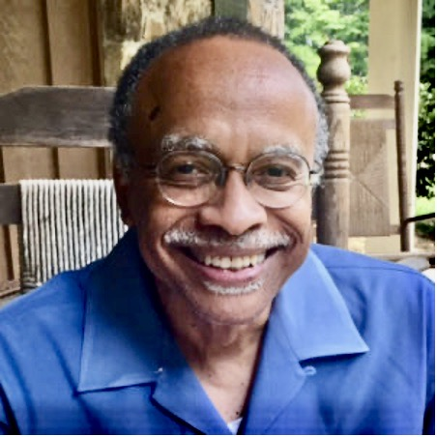
GROWING EDGE Conversation Starter—May, 2021
Episode 32: A Conversation with Luther E. Smith, Jr., Ph.D.
For our May, 2021 podcast, it was an honor and joy to speak with our friend Luther E. Smith Jr., Ph.D., Professor Emeritus of Church and Community at Candler School of Theology, author, educator, pastor, mystic, and elder. Our topics ranged far and reached deep: How identity is shaped and expanded. How conversations about race could be more authentic. How to talk with open hearts, even when it isn’t comfortable. What it meant for Luther to follow a spiritual calling that led him, as friend and scholar, to Howard Thurman.

1. Luther said that the stories his parents told when he was growing up, as well as things he learned at church, shaped his sense of identity. They gave him a sense of history, responsibility, resilience, and pride, and imparted information he needed for survival. Can you recall similar stories that helped shape your identity? Stories that celebrated the kind of courage you’ve needed to carry on?

2. Luther talked about how some of his white students were uncomfortable talking about white identity because it was not discussed directly at home or in their church. If you are white, were discussions of white identity part of your growing up? If not, why do you think that is? What does it mean to you to have “a white identity”?

3. Dr. Luther Smith spoke about how is study of the works and life of Howard Thurman was never a singularly academic pursuit, but rather a spiritual calling and journey of the heart. Was there a pursuit or path in your life that called to you and you listened? Can you talk a little about what this was like? Did you have support? What changed for you as a result of following a calling of the heart?

4. In April, a former Minneapolis police officer was convicted on three counts for the murder of George Floyd, a moment lifted up by many as setting a new precedent in racial justice. Has your view of racial injustice changed during the past year? What can we do in our daily lives to help dismantle systemic racism?

Some Approaches to this Month’s Questions

You may want to explore the podcast and Questions of the Month privately, through journaling and silent reflection. But we urge you to consider gathering online for an exploration with one or more family members or friends. If that idea appeals to you, look into using Zoom, Facetime, Skype or some other video platform or talk with each other while practicing safe social distancing.

If you aren’t familiar with Zoom, it’s easy to learn and has proven a wonderful way to host “face to face” conversations during the pandemic. A full-featured Basic Plan with unlimited meetings is free. There’s a 40 minute time limit on conversations among three or more, but you can log right back on for another 40 minutes. If the technology baffles you, check for online instructions, or get on the phone and ask any middle-schooler you know!

For group explorations, we first listen to the podcast individually or together. Then, before you meet, review the Circle of Trust Touchstones from the Center for Courage & Renewal. They’re designed to create safe space for open-hearted dialogue on a wide range of topics.

As convener, read the Touchstones aloud—or ask others to read them aloud—and let people comment on them if they wish. Remind people of how important it is to make sure everyone gets ample time to speak and be heard. Then take a moment of quiet before inviting people to speak.

Begin the conversation by reading the Questions of the Month, then inviting people to respond whenever they are ready. No “forced marches” around the circle! As the Touchstones advise, listen to what people have to say without any cross-talk. Ask honest and open questions to help them say more, if they wish, but avoid trying to “fix, save, advise, or correct each other.”

We need to find every way we can to reweave community during these hard times—and one of those ways is gathering online for conversations about things that matter. Give it a try!

