Conversation Starter

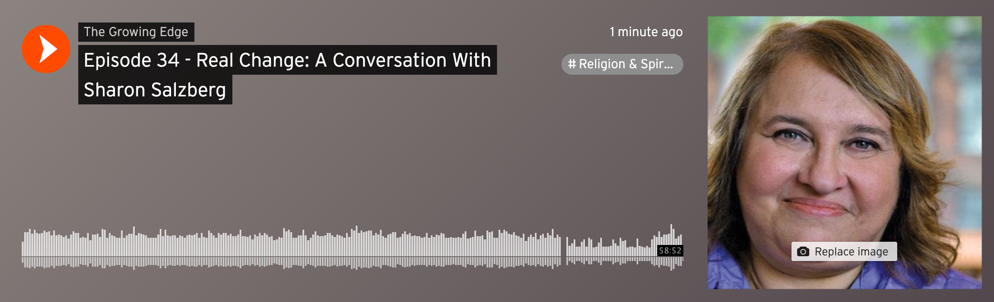

Episode 34: Real Change—A Conversation with Sharon Salzberg

For each episode we offer a conversation starter you can download at our website. You can use this with a small group, or for your own meditation or journaling.

In this episode with Sharon Salzberg—widely respected and much-loved mindfulness teacher—we explore suffering; feeling what we feel and yet not getting stuck in our emotions; the importance of balance and self-care in avoiding burnout; flexibility of attention and light-heartedness; and the role of meditation in sustaining our work in the world.

1. Do you have a personal practice that helps you stay grounded and focused? If you do, are you getting enough time with that practice and if not, why?

2. Sharon told the story of being a young woman from a fractured family background, and how mindfulness and meditation on the nature of suffering helped her feel that she was not so alone. We all have joys and struggles, wounds and gifts. What does not being alone in your life experiences, including suffering, mean to you? Who has been a good companion for you? How have you been a good companion for another?

3. Sharon spoke about our tendency to focus on something difficult or mistakes we’ve made, forgetting all the things we’ve done right. If you’ve experienced this kind of tunnel vision, what gives you a more inclusive perspective? Does this perspective come naturally or does it require intention?

4. Sharon spoke about anger as one of those feelings we’re not “supposed to have.” She made the point that there’s no shame in having feelings, but we need to be intentional about not getting stuck in any emotion that narrows our ability to problem-solve or gain perspective. In our culture many of us were taught certain emotions were acceptable and others were to be suppressed, avoided or ignored. What is your experience with emotions that are difficult or intense? What’s scary about “we feel what we feel”? What brings relief in “we feel what we feel”?

5. What was your experience of Sharon’s guided meditation. What came up for you during that time?

Some Approaches to this Month’s Questions

You may want to explore the podcast and Questions of the Month privately, via journaling and silent reflection. But please consider gathering online for an exploration with one or more family members or friends. If that idea appeals to you, look into using Zoom, Facetime, Skype or some other video platform or talk with each other while practicing safe social distancing. We are also deeply grateful that, with the availability of the Covid-19 vaccine, it is sometimes possible to gather safely to have these conversations in person.

